E-learning applied to computer vision
RNDr. Pavla Ňuňuková
Department of Applied Computer Science
Comenius University Bratislava, Slovak Republic

ABSTRACT
The paper is about the methodology of e-learning applied in computer vision. There exists an interactive textbook of computer vision in Slovak language but the only difference between traditional book and this textbook is that one can read it on internet and use interactive java applets to demonstrate the principles in the lecture. The ambition of this paper is to propose the way, how to change this textbook to convert it to real e-learning lessons with all tools that e-learning can provide to make it more effective and really interactive.
KEYWORDS
e-learning, graphics, feedback, learning management system
- INTRODUCTION
In computer vision there exist many text books and many lessons, but just few of them are available online. Some of the lessons include documents and presentations but nothing more. There also exist few projects that are more complex in their approach. Our goal is to create complex e-learning project in computer vision using our own methodology, where also important parts as feedback or testing should be included. The part of this goal is also the real usage of this project in distance learning with the possibility of experimental evaluation of its main components and features.
- Theory
The outline of the intended new methodology is the following: we take ADDIE [1] as a basic structure and we will extend it with the very first step from Dick and Carey model [2] which is “Identify goals”. In this paper we describe each step and show some possibilities that according to us improve the traditional methodology ADDIE.
2.1 Identify goals
First of all is important to think about what we are going to teach. We have three different types of lessons [3], receptive, directive and guided discovery. Receptive lesson is mostly informative and we have just a few exercises. Directive is more interactive and we require frequent responses from the students. Guided discovery is form where students have the possibility to work with real life situations. According to the result of our decision we are able choose the best method.
2.2 Analysis
It is necessary to think about the content and the time that student should spend on the lesson. Together with the goals from the first step this will form the outline of the complete lesson. In next step we are working with concrete tools and it must be really clear what we want.
2.3 Design
In the year 2006 the virtual textbook Digital Image Processing by Gábor Blázsovits [4] has been published on the Faculty of mathematics, physics and informatics of Comenius University in Bratislava (Slovakia). This book (see Figure 1) was prepared for students of image processing.

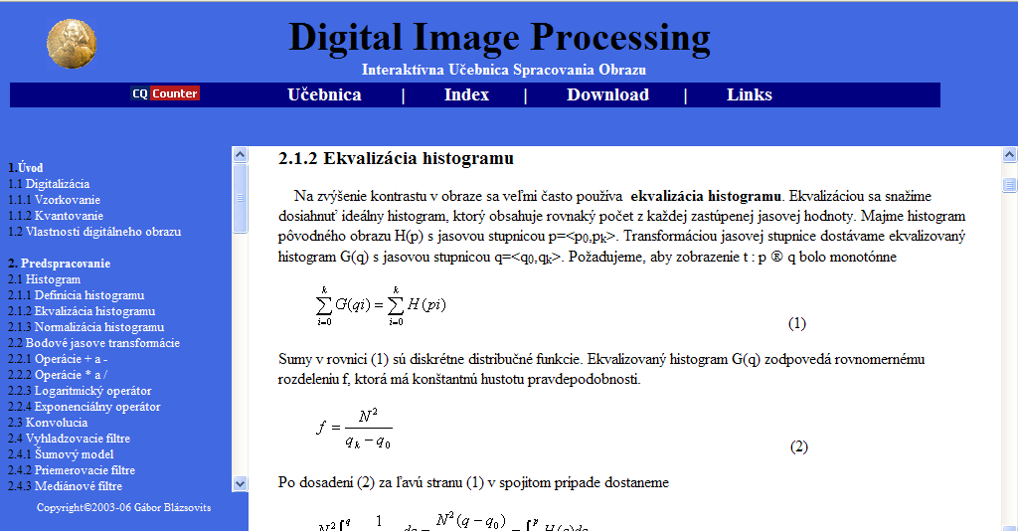
Figure 1 – DIP

In traditional ADDIE is this step not exactly described. What we want to do is to elaborate it. Our work is to add to the work of Gábor Blázsovits some more e-learning tools. We want this work to be used as an e-learning project for one semester of computer vision on the Department of applied informatics. Now we have these lessons guided by teachers in classes. So we need to create some more complex e-lessons.
2.3.1 Testing at the end of each topics
We are working on adding some important tools as testing during the text and also at the end of topic. At the end of each chapter there will a set of questions as a comprehension check. For these questions, the answers will be available. These questions are for students to clear all the details. The template of test after each topic is going to be different. Some questions will be a questions with short answers, some will be test questions with the possibility to choose answer A to E. In case of test questions we want to have more possibilities of good answers. Sometimes it will be just one and in other case can be up to 3 good answers. It is good for the students to see that answer can be given in different forms.

Example
Čo znamená 4-susednosť? (What does it mean 4-conection?)
A: 4-susedia daného obrazového elementu sú body s jednotkovou vzdialenosťou v metrike D₄ (4 neighbors of given image element are points with the distance 1 in D₄ metrics)
B: 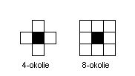

C:
D: susedia do vzdialenosti 4 bodov od daného obrazového elementu (neighbors up to distance 4 point from given image element)
E: žiadna z možností A-D nie je správna (none of the answers A-D).
2.3.2 Defining e-lesson
We are preparing asynchronous e-learning lessons therefore our second change, we are working on is to define the amount of text for every week or standard lesson. We want that this e-learning project will take whole semester. Therefore it is necessary to define amount of text that should be done every week. It is important for the students to know, because of testing during the semester. It will also help the students to plan the time for learning. It is not necessary for us that students will learn weekly. It is their decision how they arrange their time.
In the virtual text book it is lot of info but we want to have more text to the textbook as comments. As it is said in [3] it is not important the way of delivering the information but the content. It will be useful for students because there will be some more examples. It can make some definitions more clear for the students. They will have the possibility to choose appropriate example for them.

Example of defining the week-work
1st week: Úvod (Introduction)
2nd week: Digitalizácia (Digitizing)
Vlastnosti digitálneho obrazu (Properties of digital image)
This is made for students to see amount of information in each week. It must be clear what knowledge are they going to get every week. It is useful also for the teacher to prepare the testing in the middle of semester. It must not be always at the same week so also the teacher knows what knowledge should the students have.
2.4 Develop
What we need to choose in this step is the form of e-lessons. They have to be uniform otherwise we can have the problem that students will be lost in different concepts of each scene in different learning management systems.
For us it is important to have some graphics in the lessons to help the student to orientate in the lesson. To find for example, all the definitions or links to the words they need. It is necessary for us is to make the graphics useful and not just as the decoration of the lesson. We will give the definitions in the beginning of the page in a different color than the rest of the lesson to be clear and easy to find. Also the examples must be clearly shown.

2.5 Implementation
This step depends on many factors. First it is University and its possibilities, second it is the learning management system. On this step we have to work to see the possibilities of our University. It is also important to know the learning management system, because we have to know whether it is free or non-free to take the costs. This part is important for the project. We also need all the tools in this learning management system to satisfy all our plans from the Design step.
2.6 Evaluation
Feedback should be a special part of e-lessons. For this we will use a part of the ČVUT model [5], not using all the questions just some of them that are relevant for us. What we are going to do is to prepare our own question forms to have the exact data from the students. This is going to be worthy for the lectors, because they will know if everything was clear. They can adapt the e-lessons for the students.
- CONCLUSION
We are on beginning of the e-learning project. We already prepared the methodology by adding a new step and describing the old ones. Now we have a set of questions as was shown in the text, which are going to be a part of each lesson and also part of the step Design. And we are working on the graphics part of e-lessons to be clear for all the students. The plan of each lesson is already prepared. We have to just finish the questions for the feedback form and implement the e-lessons prepared with the new methodology to the learning process.
ACKNOWLEDGEMENT
This paper was supported by the grand APVV-20-056105: Tools for processing and visualization of tomographic and confocal data.
REFERENCES
[1] “ADDIE Instructional Design Model | Presented by Intulogy” [online], published 2004;
http://www.intulogy.com/addie/
[2] “Dick & Carey Model” [online]; http://www.umich.edu/~ed626/Dick_Carey/dc.html
[3] Clark, R. C., Mayer, R. E., 2003. e-Learning and the Science of Instruction. Pfeiffer, San Francisco, USA.
[4] Blázsovits, G., 2006. Interaktívna učebnica spracovania obrazu. Knižničné a edičné centrum FMFI UK, Slovakia
[5] “dotaznik1”[online], [cit. 2008-01-20]; http://212.80.75.242:500/fmi/iwp/cgi?-db=dotaznik1&-loadframes

